ANOTHER WAY TO THINK:

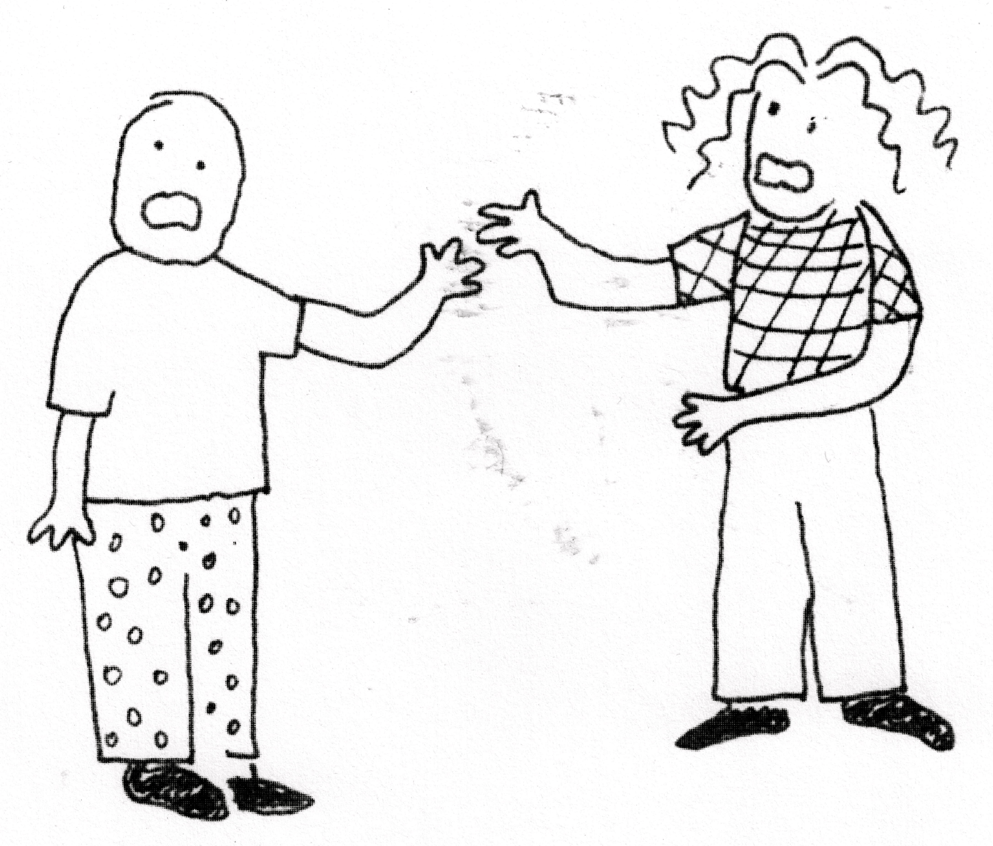
HOW to TRANSLATE YOUR JUDGMENTAL, CRITICAL and BLAMING THOUGHTS toward YOURSELF and OTHERS into
COMPASSIONATE COMMUNICATION

Based on the book NONVIOLENT COMMUNICATION by Marshall Rosenberg

Before you speak, you think. This four-week workshop will help you formulate empathetic ways of thinking that can profoundly affect what you say.

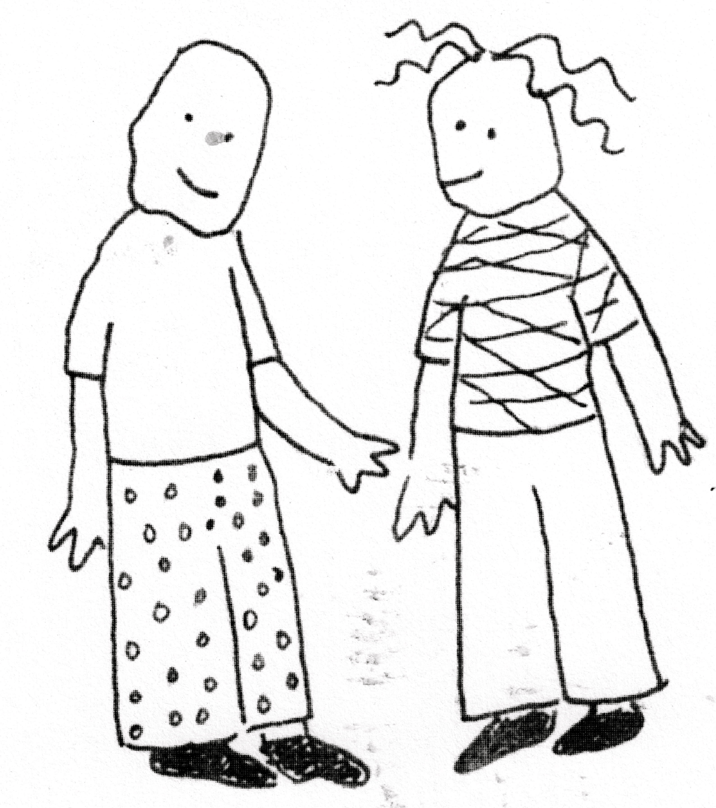
JANUARY 5 - JANUARY 26

MONDAYS 6 - 8

GARRABRANDTS ROOM, BANGS CENTER
(top of the stairs)
AMHERST

no fee, but participants are asked to purchase a workbook (approximately $10.00)

led by Robert and Sharon Raymond of Shutesbury, long-time practitioners of NVC
for more information or to register, please contact sharon@simpleshoemaking.com

