Time | Activity | Meet-Your-Neighbors  Scavenger Hunt  FIND SOMEONE HERE (and write their  name) WHO...  1. has lived in Amherst at least 30 years  ________________  2. has lived in Amherst less than a year  ________________  3. is over 70 years old _________________  4. is under 22 years old _________________  5. was born in Amherst _________________  6. was born in another country  _________________  6. has solar panels on their roof  _________________  7. rides a bike _________________  8. has chickens _________________  HOW MANY DID YOU FIND? GET ACQUAINTED!
12:30 | Registration and GET-AQUAINTED  scavenger hunt  Music by ARHS Jazz III led by Kara Nye
12:55 | Opening Songs by Peter Blood & Annie Patterson* (words on back of program)
1:05 | Welcome
1:15 | Amherst Past
1:30 | Amherst Present
1:40 | Amherst Future––Transitioning to Community Resilience
2:00 | Participatory Thinking: A “World Café”  Current assets–––Future aspirations
2:45 | Break Time (snacks in the lobby)
Song: “The Transition Town Hop” (words on
back of program)

3:00 | Introduction to “Open Space” groups
3:25 | Session One of Open Space
4:05 | Break Time (snacks in the lobby)
4:10 | Song by Emma & Eli Ayres
4:20 | Session Two of Open Space
5:00 | Form a Council of Working Groups
5:30 | Closing
_____________________________________________
* For more information on Annie & Peter and their music, see their website: www.quakersong.org

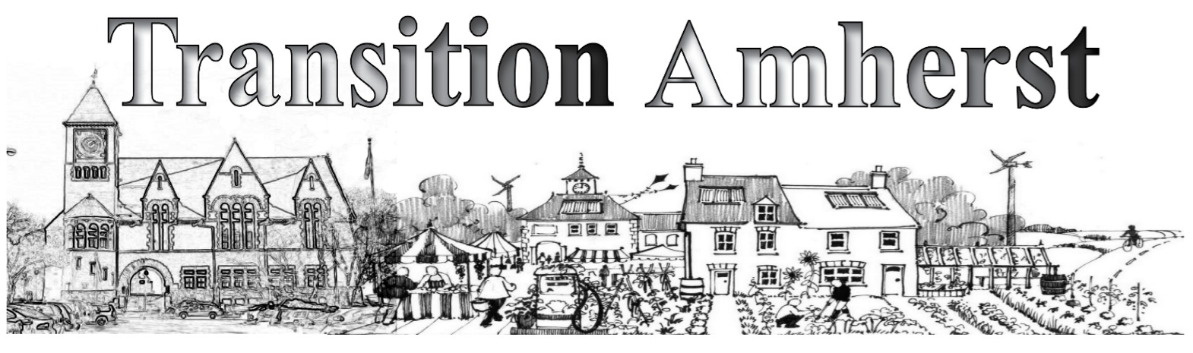
All Things Community:
Celebrating Amherst in Transition

A tribute to what’s happening today and what’s possible tomorrow

Building resiliency in the face of peak-oil, climate change, & economic instability

Saturday, October 13, 2012 – 12:30-5:30 p.m.

Amherst Middle School, Chestnut St.

Agenda

